Codon optimised gene sequences (S1)
SEQ Arabidopsis thaliana FAE1: 1521 bp;
Composition 458 A; 281 C; 322 G; 460 T; 0 OTHER
Percentage: 30.1% A; 18.5% C; 21.2% G; 30.2% T; 0.0%OTHER

Molecular Weight (kDa): ssDNA: 470.34 dsDNA: 937.5
>Arabidopsis thaliana FAE1 sequence optimised for Saccharomyces cerevisiae

1 ATGACATCTG TAAATGTGAA GTTGTTGTAC AGATACGTTT TGACCAATTT CTTCAATTTA
61 TGTTTGTTCC CACTGACTGC GTTCTTAGCT GGTAAAGCCA GTAGATTAAC CATAAACGAT
121 TTGCACAATT TCTTATCCTA TCTTCAACAT AACCTGATAA CTGTGACTTT GCTATTTGCG
181 TTTACTGTGT TTGGTTTGGT ACTTTACATC GTAACCAGAC CAAATCCGGT ATACTTGGTT
241 GATTATAGCT GCTATCTACC TCCACCACAT CTGAAAGTCT CAGTGTCCAA AGTTATGGAT
301 ATCTTCTATC AGATTAGAAA GGCTGATACC TCATCAAGAA ATGTCGCATG TGATGATCCA
361 TCCTCTTTGG ACTTCTTGCG TAAAATTCAA GAAAGGTCTG GCCTAGGTGA TGAAACATAT
421 AGCCCAGAAG GGTTAATTCA TGTCCCTCCC AGGAAAACCT TTGCTGCTTC AAGAGAAGAG
481 ACAGAGAAGG TGATTATTGG GGCCTTAGAA AACCTGTTTG AAAACACGAA AGTTAATCCA
541 AGAGAAATTG GCATATTGGT TGTCAATTCC TCCATGTTTA ACCCTACACC TAGTCTTTCC
601 GCAATGGTGG TGAATACCTT CAAGCTTCGT AGTAATATCA AATCGTTTAA CCTTGGCGGT
661 ATGGGTTGTT CTGCTGGAGT TATCGCCATC GATTTGGCCA AAGACTTATT GCATGTACAT
721 AAGAACACAT ATGCATTAGT CGTTTCAACA GAGAATATTA CACAAGGTAT ATATGCAGGA
781 GAAAATCGTA GTATGATGGT GTCTAACTGT CTATTTAGGG TAGGAGGTGC TGCCATACTA
841 CTGAGCAACA AATCAGGGGA TAGGAGAAGA AGCAAATATA AGTTAGTTCA CACTGTCAGA
901 ACACATACTG GTGCTGATGA CAAATCCTTT AGATGTGTTC AACAGGAAGA TGACGAATCT
961 GGTAAGATAG GGGTTTGTTT ATCAAAAGAT ATTACGAACG TTGCAGGCAC TACCTTGACT
1021 AAGAATATAG CGACTTTGGG ACCCTTAATT TTACCGTTAA GCGAGAAGTT TCTATTCTTC
1081 GCTACTTTTG TAGCTAAGAA GTTGTTGAAA GATAAAATCA AACACTACTA TGTTCCTGAC
1141 TTTAAACTGG CCGTTGACCA CTTTTGCATT CATGCGGGTG GAAGAGCAGT TATAGATGAA
1201 TTAGAGAAGA ATCTTGGCCT ATCACCCATT GATGTCGAAG CTTCAAGAAG TACATTACAC
1261 AGATTTGGTA ACACGTCTAG TAGTTCGATT TGGTACGAGT TGGCATACAT TGAAGCAAAA
1321 GGCAGGATGA AGAAAGGTAA TAAGGCTTGG CAAATCGCAC TTGGTTCTGG TTTTAAATGC
1381 AATTCTGCTG TTTGGGTTGC ACTAAGAAAT GTCAAAGCTT CTGCCAACTC TCCTTGGCAA
1441 CATTGCATTG ACCGTTATCC AGTCAAGATC GATTCGGACT TGTCTAAGTC GAAAACGCAT
1501 GTACAGAATG GAAGATCATA A

SEQ Arabidopsis thaliana GPAT5: 1509 bp;
Composition 411 A; 297 C; 338 G; 463 T; 0 OTHER
Percentage: 27.2% A; 19.7% C; 22.4% G; 30.7% T; 0.0%OTHER

Molecular Weight (kDa): ssDNA: 466.43 dsDNA: 930.2

>Arabidopsis thaliana GPAT5 sequence optimised for Saccharomyces cerevisiae
1 ATGGTTATGG AACAAGCAGG CACTACATCA TATTCTGTAG TGAGTGAGTT CGAAGGTACG
61 ATCTTGAAGA ATGCCGACTC TTTTAGCTAT TTCATGCTTG TAGCGTTCGA AGCAGCTGGT
121 TTGATTAGAT TCGCCATTTT GCTATTTCTA TGGCCAGTAA TCACCTTACT AGACGTCTTT
181 AGTTACAAGA ATGCCGCCTT AAAACTGAAA ATCTTTGTCG CAACTGTTGG ATTGAGAGAA
241 CCTGAAATTG AAAGTGTAGC AAGAGCCGTT CTTCCAAAAT TTTATATGGA TGATGTTTCA
301 ATGGATACTT GGAGGGTCTT TTCAAGTTGT AAAAAACGTG TTGTAGTCAC AAGAATGCCA
361 CGTGTTATGG TTGAACGTTT CGCTAAAGAG CACTTGAGAG CTGATGAAGT AATAGGCACT
421 GAGTTAATTG TCAATAGGTT TGGTTTTGTT ACAGGATTAA TCAGAGAAAC CGATGTCGAT
481 CAATCAGCCT TGAACAGAGT GGCGAACTTA TTCGTAGGTA GAAGGCCACA ATTAGGCTTA
541 GGGAAGCCCG CCCTGACAGC ATCGACAAAC TTCTTGAGCT TATGCGAAGA GCACATTCAT
601 GCTCCAATTC CTGAGAATTA CAATCATGGT GATCAGCAAT TGCAGTTGAG GCCGTTACCC
661 GTGATATTTC ACGATGGAAG ATTGGTTAAG AGGCCGACGC CTGCAACTGC ACTTATTATA
721 CTGTTGTGGA TTCCTTTCGG TATAATACTA GCTGTTATAA GAATCTTTCT TGGGGCGGTT
781 CTGCCATTGT GGGCAACTCC ATACGTGTCT CAGATATTTG GAGGGCACAT AATTGTTAAA
841 GGCAAGCCAC CCCAACCACC AGCTGCCGGT AAATCGGGAG TCCTTTTCGT CTGCACGCAT
901 AGAACTCTTA TGGACCCCGT GGTTCTATCT TACGTTTTAG GTAGATCTAT TCCTGCCGTC
961 ACATATTCTA TCTCCAGATT GTCGGAGATT TTGTCCCCTA TACCAACGGT AAGATTGACT
1021 AGAATCAGGG ACGTAGACGC AGCTAAGATT AAGCAACAAT TGTCTAAAGG TGACCTAGTG
1081 GTGTGTCCAG AAGGTACAAC ATGTAGAGAA CCTTTTCTAC TAAGATTTTC TGCTCTTTTC
1141 GCAGAATTAA CTGATCGTAT TGTGCCGGTT GCGATGAACT ATAGAGTAGG CTTCTTTCAT
1201 GCAACTACAG CTAGAGGATG GAAAGGTTTG GACCCTATTT TTTTCTTTAT GAACCCTAGA
1261 CCGGTTTATG AGATTACCTT TCTGAATCAA TTGCCAATGG AAGCTACCTG TTCCAGCGGT
1321 AAATCCCCTC ATGATGTTGC TAATTACGTG CAACGTATCT TAGCTGCTAC CTTAGGTTTT
1381 GAATGCACCA ACTTCACAAG GAAAGATAAG TACAGAGTCT TAGCTGGTAA TGATGGCACT
1441 GTTTCCTATT TGTCACTGTT AGATCAGTTA AAGAAAGTTG TGTCAACCTT TGAACCCTGT
1501 TTGCATTAA
Plasmid maps (S2)
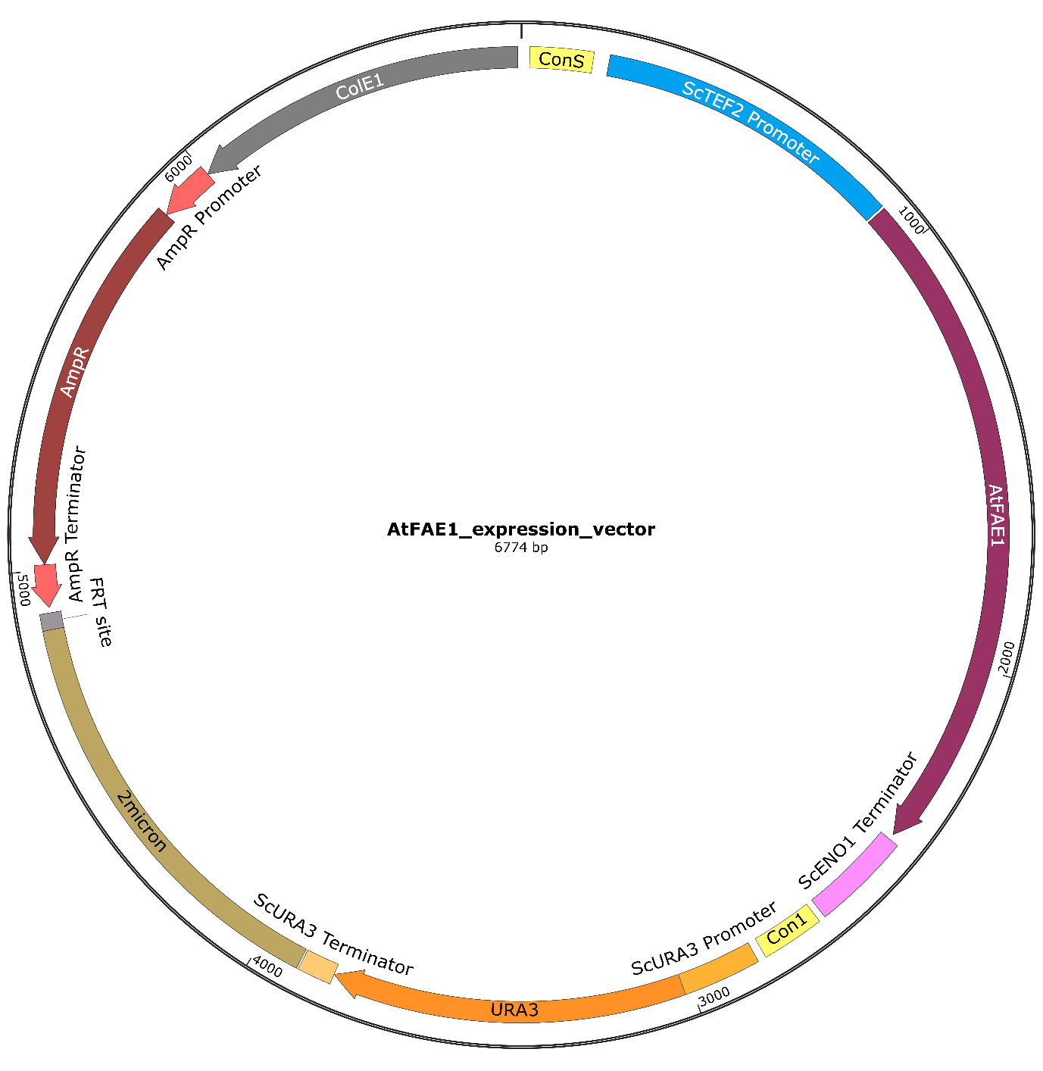
Figure S1: Plasmid map of the Arabidopsis thaliana FAE1 expression vector. Plasmid map for the expression of the A. thaliana FAE1 gene, which was codon optimised for expression in Saccharomyces cerevisiae. Plasmid remains in the yeast cell for expression of single gene (FAE1).
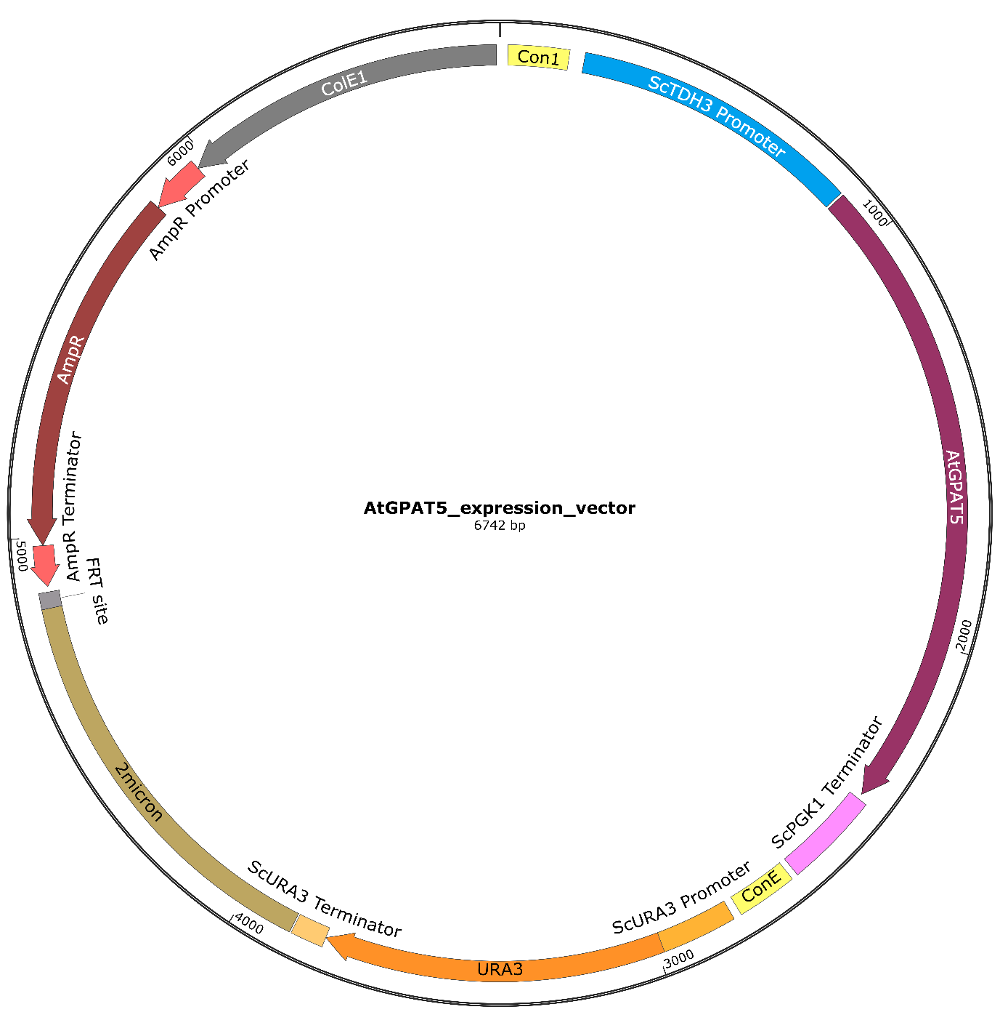
Figure S2: Plasmid map of the Arabidopsis thaliana GPAT5 expression vector. Plasmid map for the expression of the A. thaliana GPAT5 gene, which was codon optimised for expression in Saccharomyces cerevisiae. Plasmid remains in the yeast cell for expression of single gene (GPAT5).
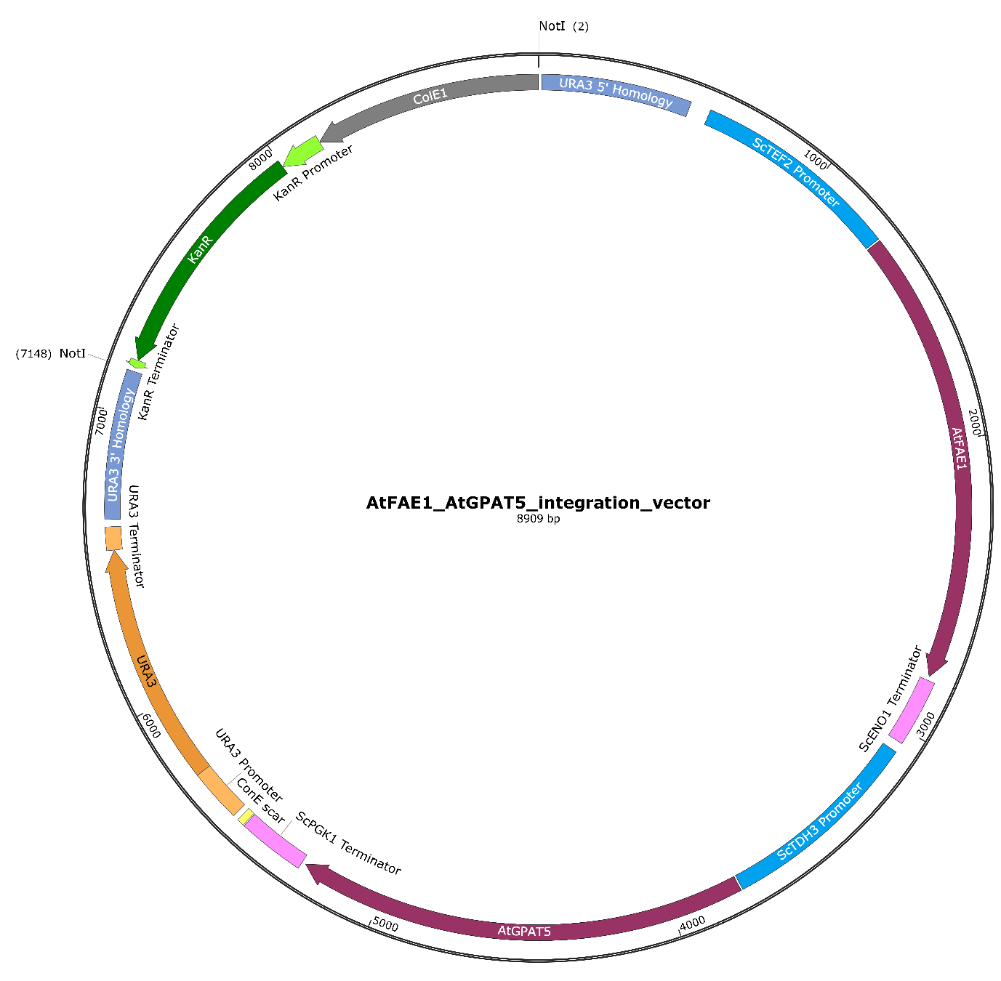
Figure S3: Plasmid map of the Arabidopsis thaliana FAE1 and GPAT5 integration vector. Plasmid map for the expression of the A. thaliana FAE1 and GPAT5 genes. The sequence of the genes was codon optimised for expression in Saccharomyces cerevisiae. Plasmid digested with NotI prior to the site-directed integration of the genes in the URA3 site in the S. cerevisiae genome for expression of the two genes.
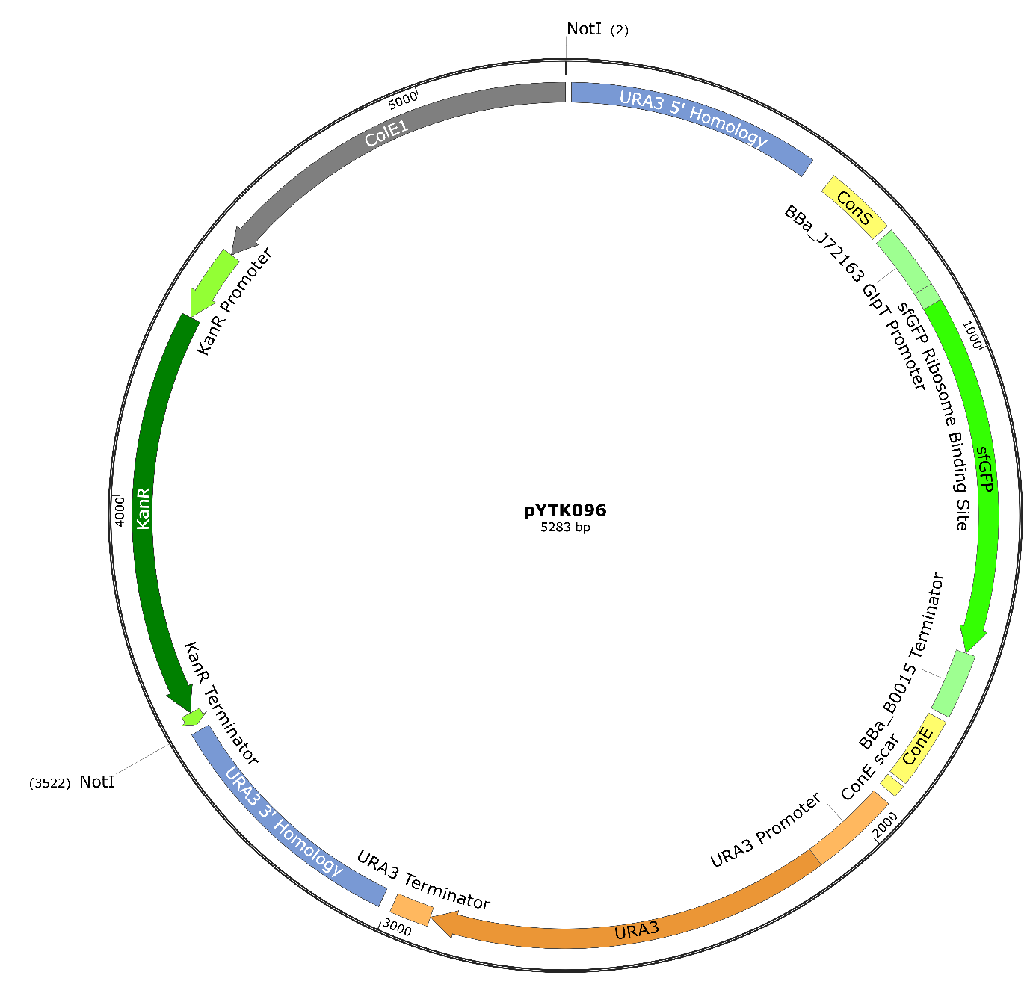
Figure S4: Plasmid map of the vector used to create the empty plasmid control. Plasmid digested with NotI prior to the site-directed integration into the URA3 site in the S. cerevisiae genome. The vector is part plasmid 96 of the MoClo kit (Addgene kit #1000000061).

Additional data for molecular dynamic simulations (S3)
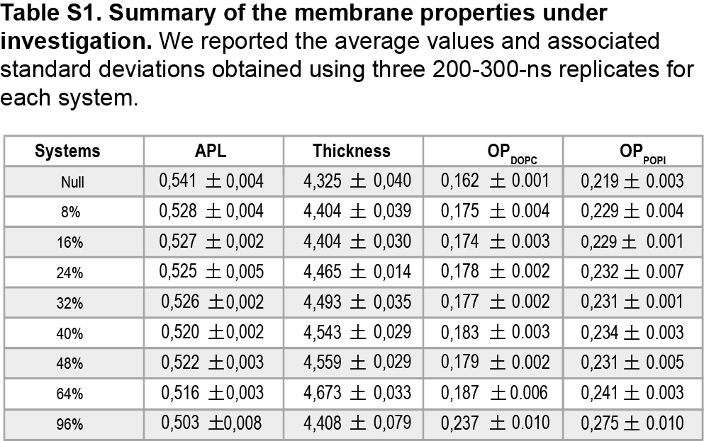
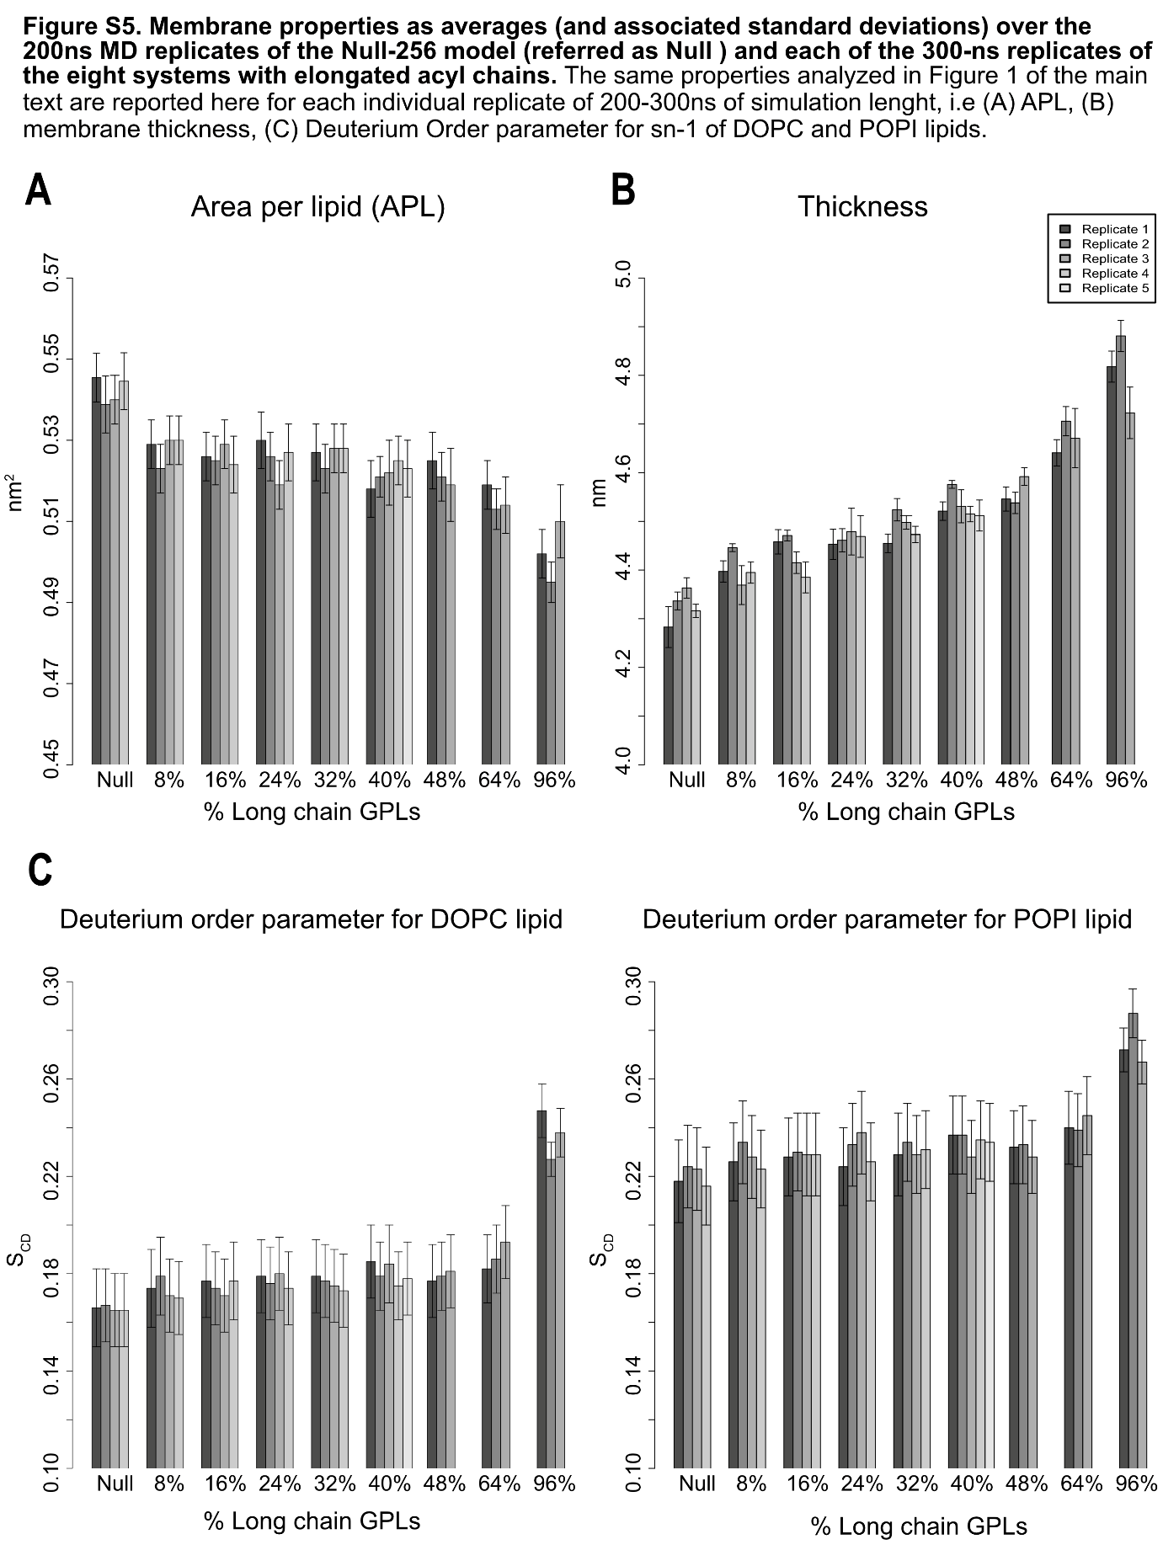

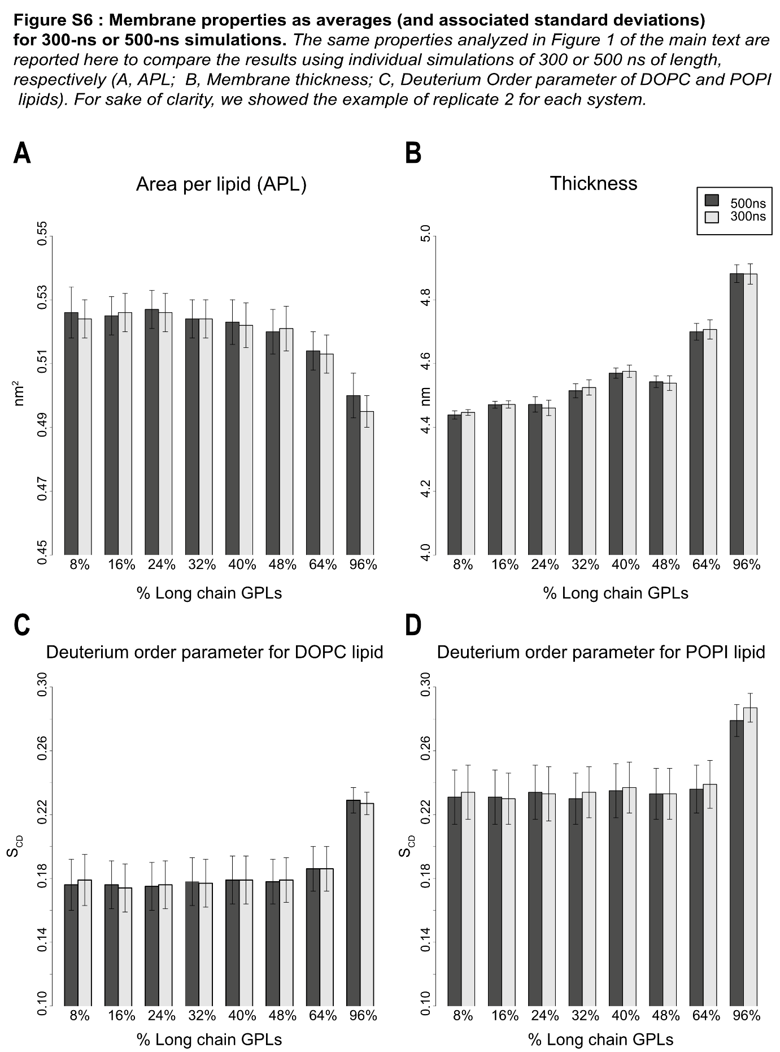

Relative abundances lipids (S4)
Table S2. Relative abundance of fatty acid chains
 |  | PM | CL | EE | TAG | Lyso-GPL
 | FAE1 | 81.30% ± 1.312 | 1.12% ± 0.228 | 8.53% ± 0.216 | 8.20% ± 1.240 | 0.85% ± 0.101
 | FAE1_GPAT5 | 70.95% ± 0.965 | 0.83% ± 0.118 | 5.24% ± 0.118 | 22.16% ± 0.791 | 0.82% ± 0.021
 | GPAT5 | 74.45% ± 1.453 | 0.75% ± 0.135 | 7.72% ± 0.418 | 16.40% ± 1.234 | 0.69% ± 0.042
 | EPC | 67.96% ± 0.476 | 1.19% ± 0.104 | 7.53% ± 0.130 | 22.20% ± 0.507 | 1.11% ± 0.071

Additional data for uptake measurements (S5)
Figure S7: Acetic acid uptake with an initial extracellular acetic acid concentration of 0.56 mM, pH 5.0. Rational regression lines were calculated using MATLAB and the 90% confidence intervals are shown by the dotted lines. The average sample response is given at each time point measured. The highest intracellular concentration of acetic acid was observed in the EPC control strain (black), while the FAE1_GPAT5 strain showed lower maximum intracellular acetic acid concentrations (grey).
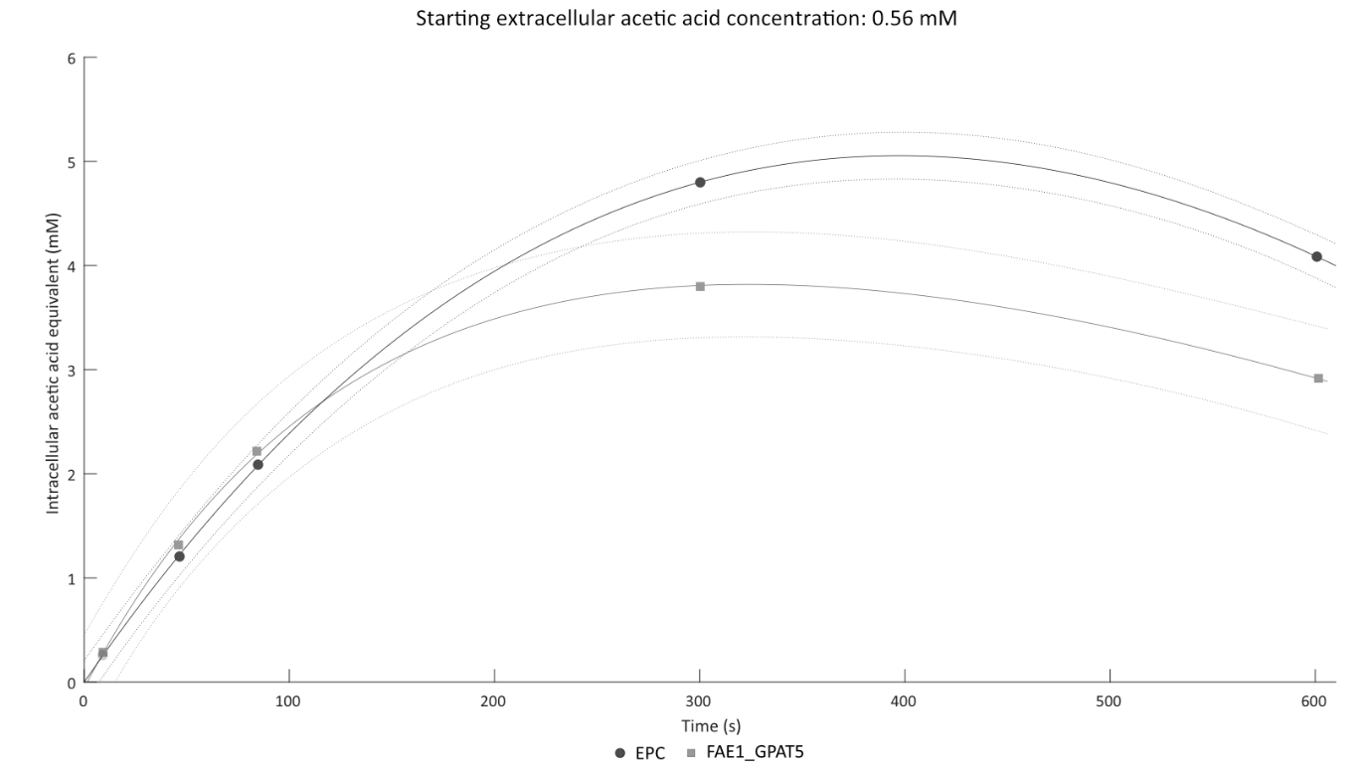

Figure S8: Acetic acid uptake with an initial extracellular acetic acid concentration of 2.4 mM, pH 5.0. Rational regression lines were calculated using MATLAB and the 90% confidence intervals are shown by the dotted lines. The average sample response is given at each time point measured. The highest intracellular concentration of acetic acid was observed in the EPC control strain (black), while the FAE1_GPAT5 strain showed lower maximum intracellular acetic acid concentrations (grey).
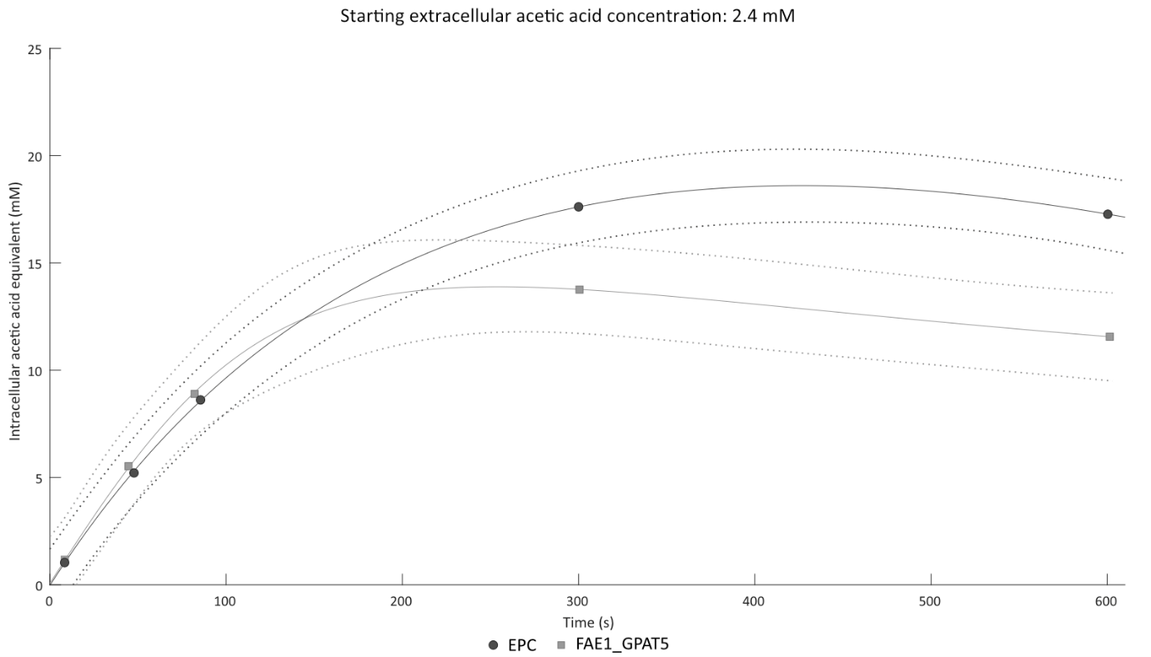

Figure S9: Acetic acid uptake with an initial extracellular acetic acid concentration of 20 mM, pH 5.0. Rational regression lines were calculated using MATLAB and the 90% confidence intervals are shown by the dotted lines. The average sample response is given at each time point measured. The highest intracellular concentration of acetic acid was observed in the EPC control strain (black), while the FAE1_GPAT5 strain showed lower maximum intracellular acetic acid concentrations (grey).
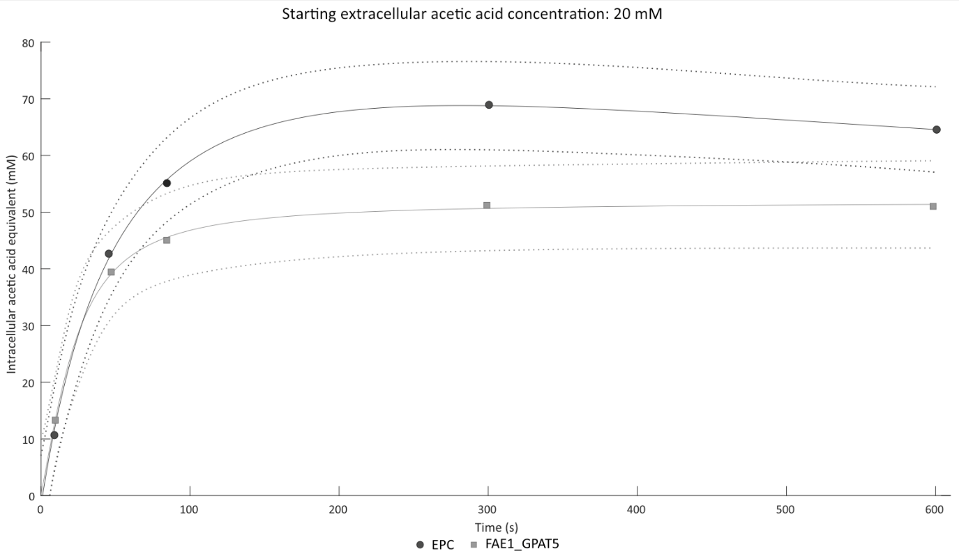

Single overexpression strains (S6)
Figure S10: Glycerophospholipid acyl chain length of plasma membrane headgroups. The figure depicts the combined chain length of the two acyl chains of glycerophospholipids obtained from total lipid analysis. The cumulative relative amounts of short- (C24-31), long- (C32-36) and very-long- (C37-48) chain glycerophospholipids are shown in the insert. GPL, glycerophospholipid.
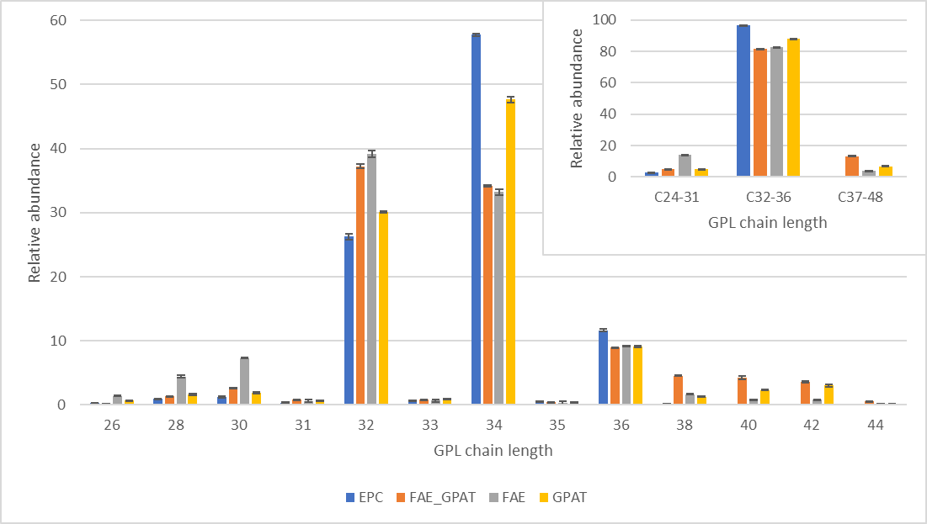

Figure S11: Relative abundance of plasma membrane headgroups. The figure shows the relative abundances of membrane-related lipid headgroups obtained from total lipid analysis, and the insert shows the cumulated amounts of different lipid classes. CDP-DAG, cytidine diacylglycerol; Cer, Ceramides; DAG, diacylglycerol; GPL, glycerophospholipid; IPC, inositol phosphorylceramide; L-GPL, lyso-glycerophospholipid; M(IP)₂C, mannosyl-di-(inositol phosphoryl) ceramide; MIPC, mannosyl-inositol phosphorylceramide; PA, phosphatidic acid; PC, phosphatidylcholine; PE, phosphatidylethanolamine; PI, phosphatidylinositol; PS, phosphatidylserine; SL, sphingolipid; TAG, triacylglycerol.

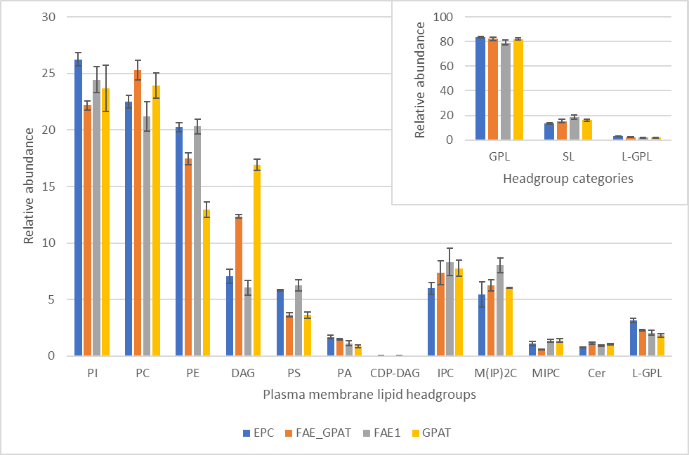

Figure S12: Acetic acid uptake with an initial extracellular acetic acid concentration of 0.56 mM, pH 5.0. Rational regression lines were calculated using MATLAB and the 90% confidence intervals are shown by the dotted lines. The average sample response is given at each time point measured.

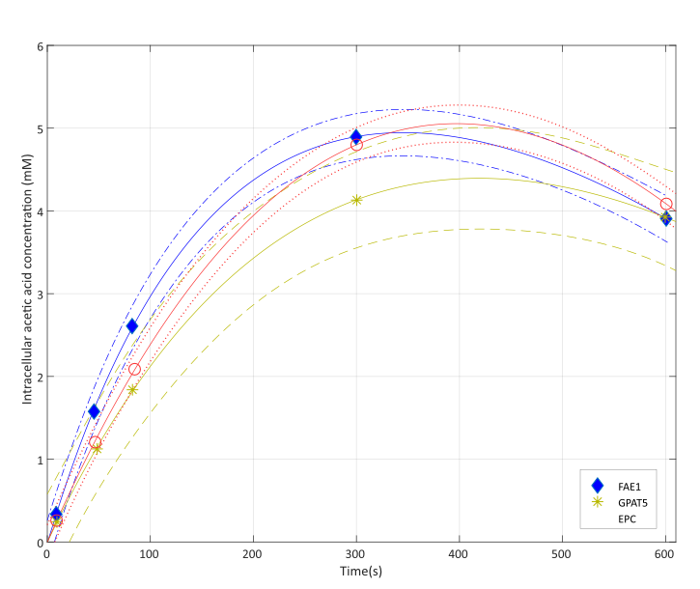

Figure S12: Acetic acid uptake with an initial extracellular acetic acid concentration of 2.36 mM, pH 5.0. Rational regression lines were calculated using MATLAB and the 90% confidence intervals are shown by the dotted lines. The average sample response is given at each time point measured.
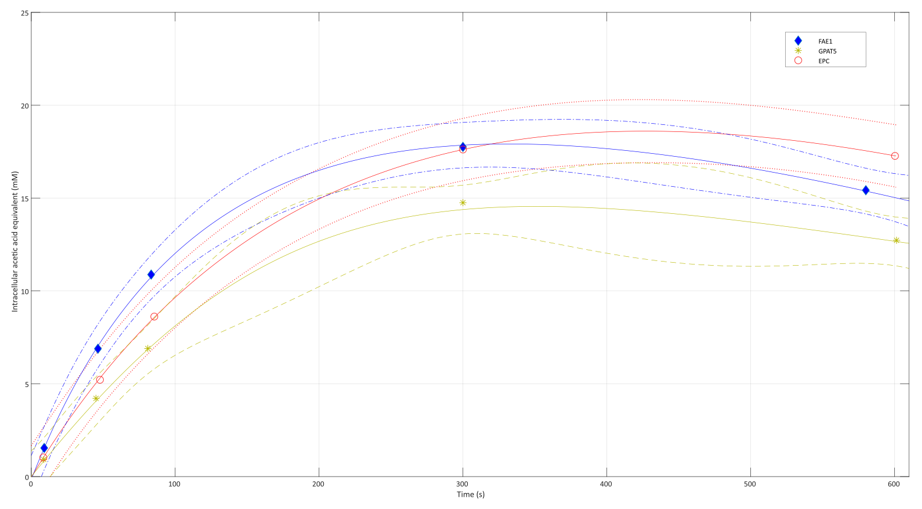
Growth profiler (S7)
Figure S13: Growth profiler. EPC (green) and FAE1_GPAT5 (blue) were grown in triplicate in the growth profiler at standard lab conditions. No significant difference can be seen between the two strains. Data on y-axis depicts calculated OD values (from green values).
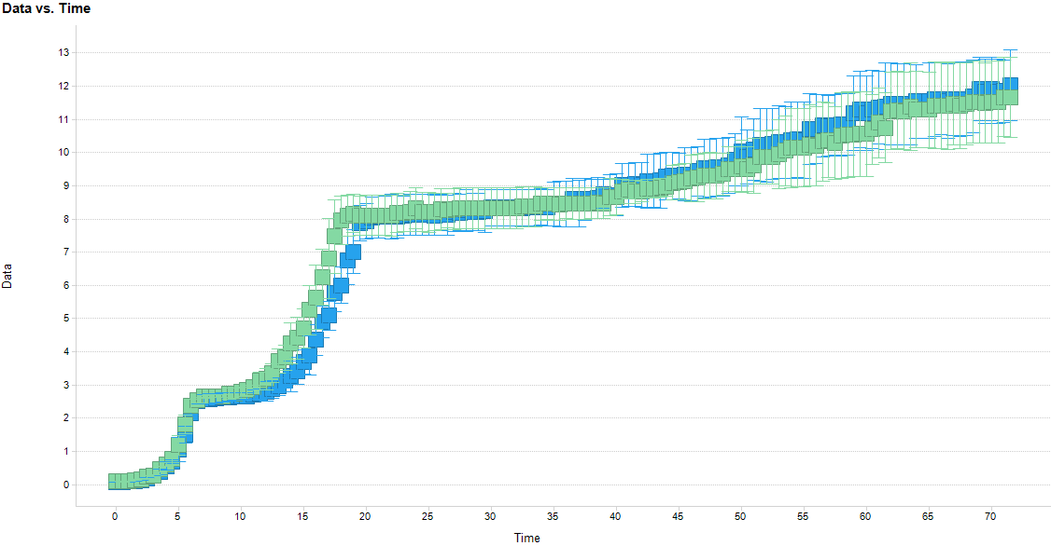

Screening lipid data (S8)
Figure S14: fatty acid methyl esterification (FAME) and Gas Chromatography (GC) analysis of EPC and FAE1_GPAT5. EPC (blue) and FAE1_GPAT5 (green) total lipid chain lengths were analysed in triplicate using FAME and GC analysis. Much higher relative abundance of long chain fatty acids is seen in the double overexpression transformant.
